Install and Import Dependencies, clone Yolov5 Repository and install all required libraries and import them

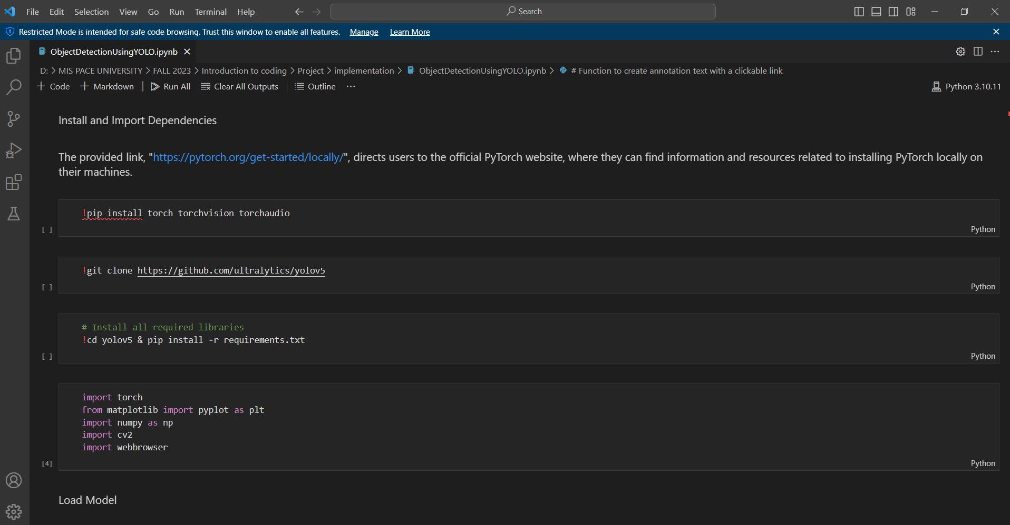

Load Model and its output

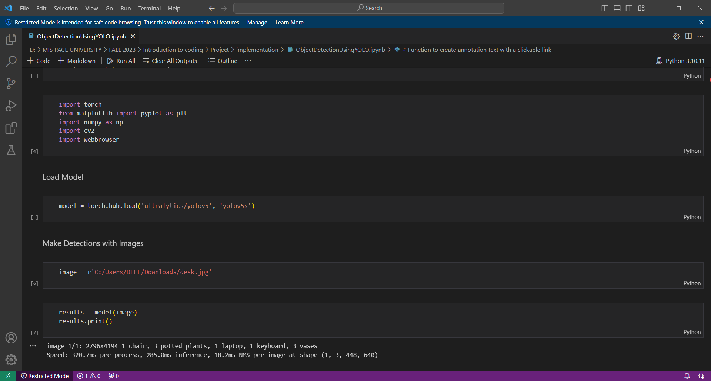

Plot it with matplotlib

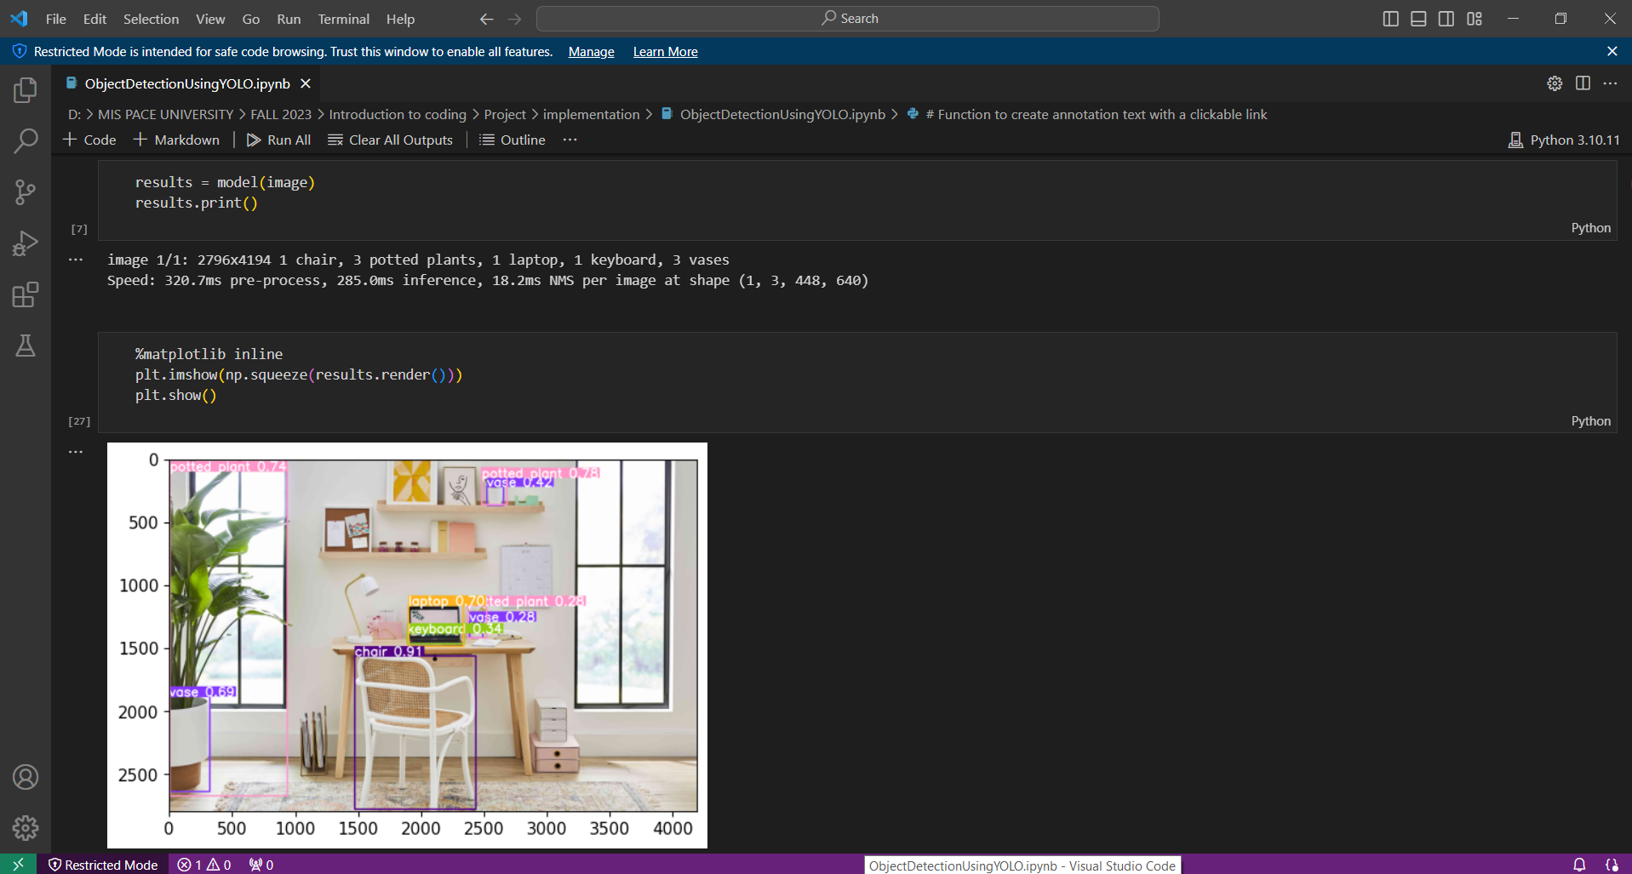

Plot it with matplotlib and links to detected objects

